Lesson 4 Demo 4
Push file to GitHub Repository

Objective: To push file to GitHub Repository

Tools required: Git

Steps to be followed:
- Create a GitHub repository
- Create a repository on the local machine
- Push the changes from the local repository to GitHub
- Check the status of the local and remote repository

Step 1: Create a GitHub repository

1.1 Go to github.com, and log in to your account.
1.2 Click on the New button to create a new repository, and enter a repository name and click on Create Repository button

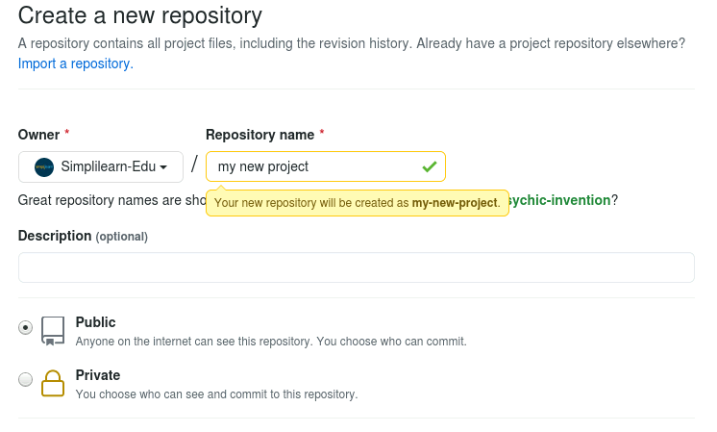

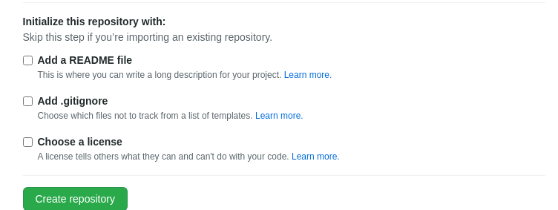

Step 2: Create a repository on the local machine
2.1 In the terminal, execute the following commands to create and initialize a Git repository
mkdir createnewproject
cd createnewproject
echo "# create new file for my project" >> README.md
git init
git add README.md
git commit -m "first commit"
git branch -M main
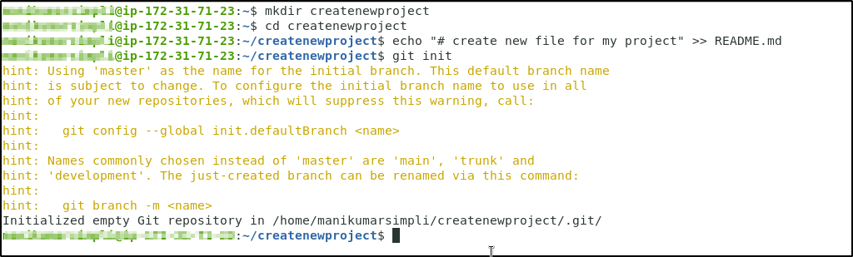
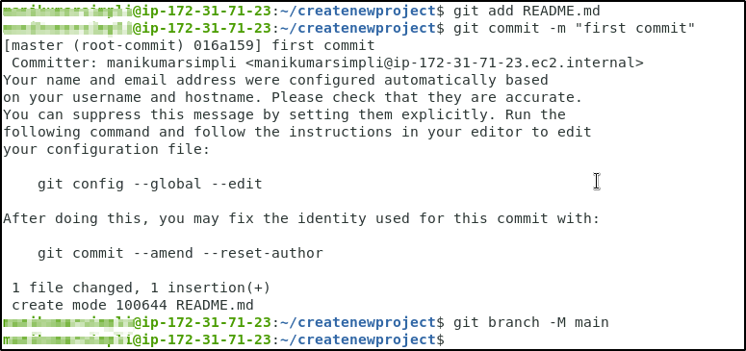
Step 3: Push the changes in the local repository to GitHub
3.1 Open the Terminal on the local machine, and use the following command to add a remote repository:
git remote add origin <Your HTTPS_URL>
3.2 Use the following command to push the changes to the remote repository:
git push -u origin main
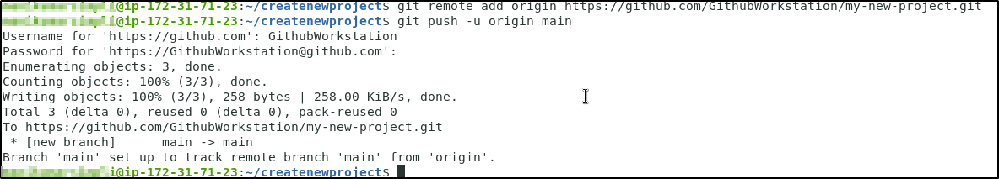
Step 4: Check the status of the local and remote repository
4.1 Run the following command to check the status of the local repository
git status
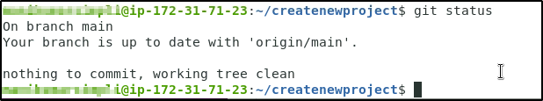
4.2 Go to github.com, and check the remote repository
